Task on VPC Transit Gateway & VPC Endpoint

1) Create one VPC, with 1 public subnet and 1 private subnet.
Step 1: Create a VPC
- Login to AWS Console.
- Go to VPC.
- Click Create VPC.
- Select VPC only.
- Enter:
  - Name: My-VPC
  - IPv4 CIDR: 10.0.0.0/16
- Click Create VPC.
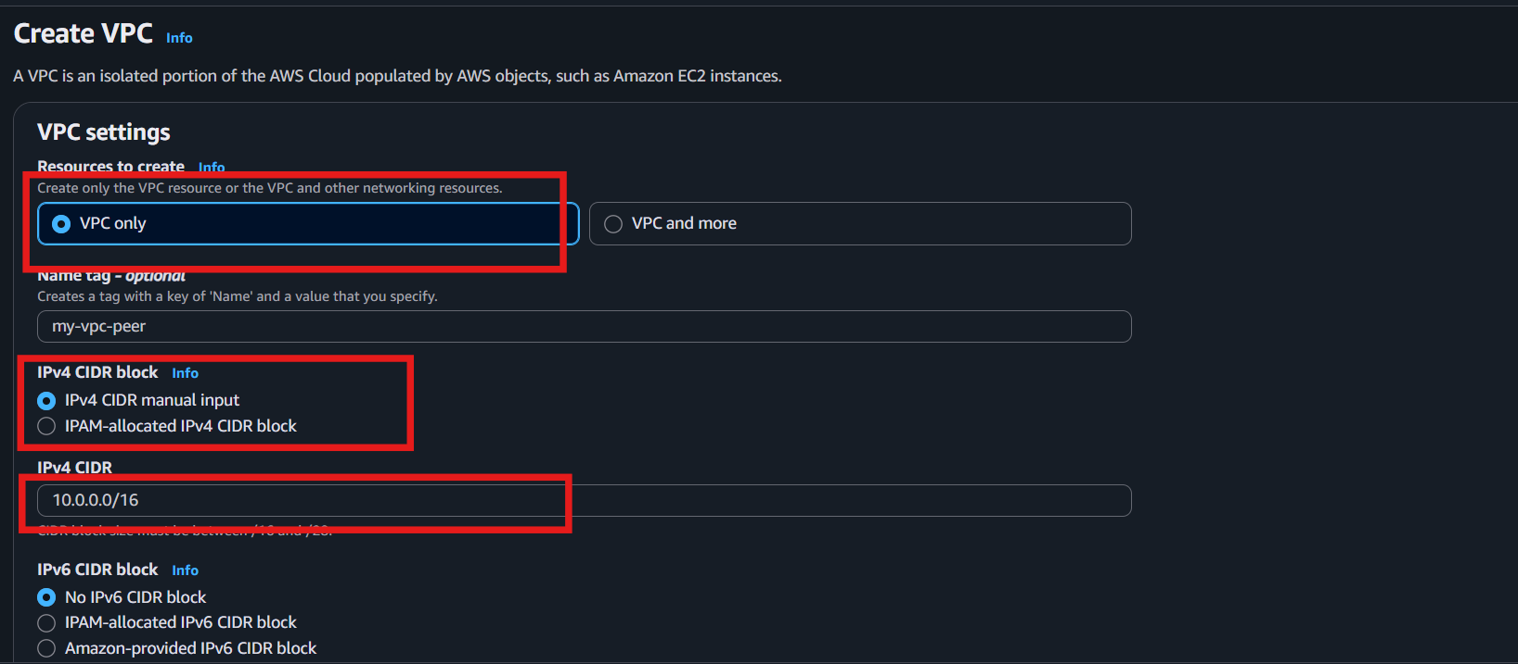

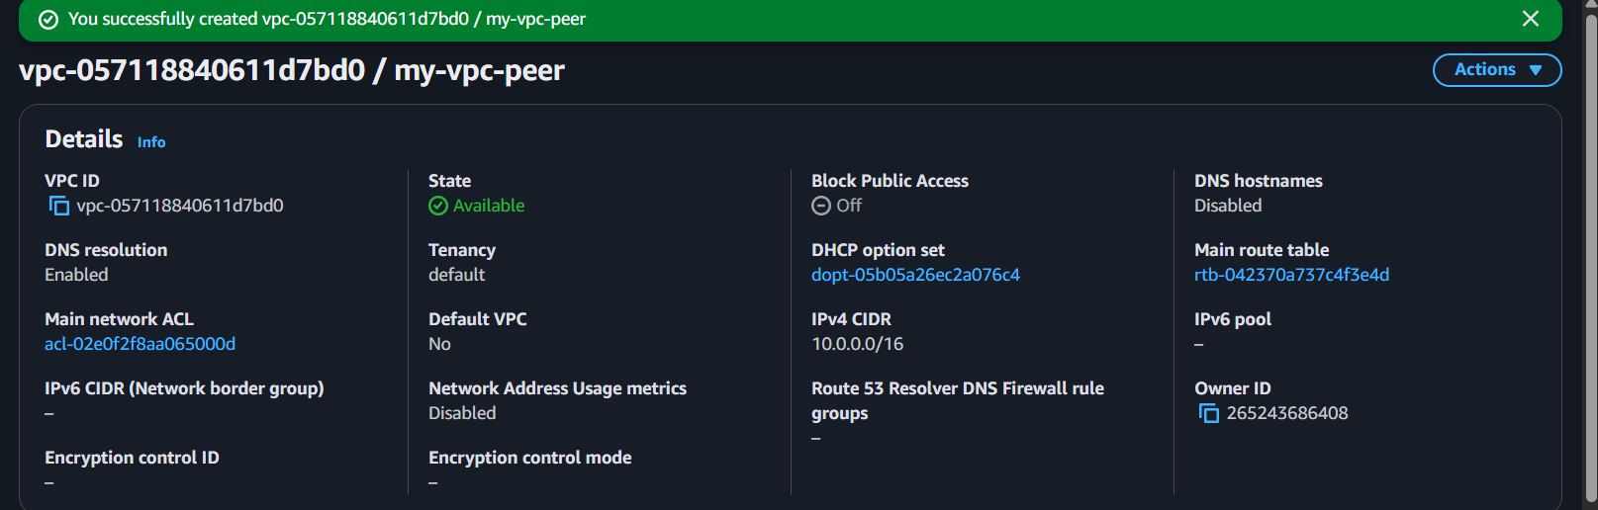

Step 2: Create a Public Subnet
- In the left menu, click Subnets.
- Click Create subnet.
- Select My-VPC.
- Enter:
  - Subnet name: Public-Subnet
  - Availability Zone: Choose any (e.g., us-east-1a)
  - IPv4 CIDR: 10.0.1.0/24
- Click Create subnet.
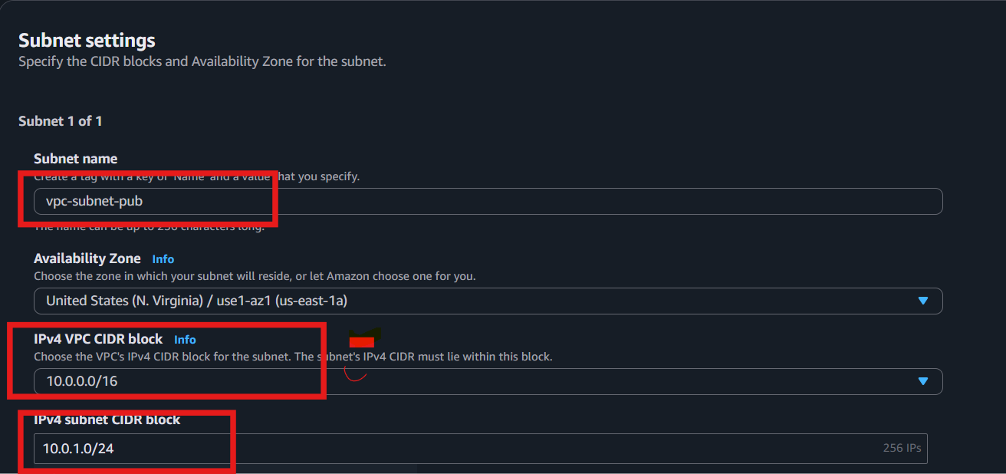
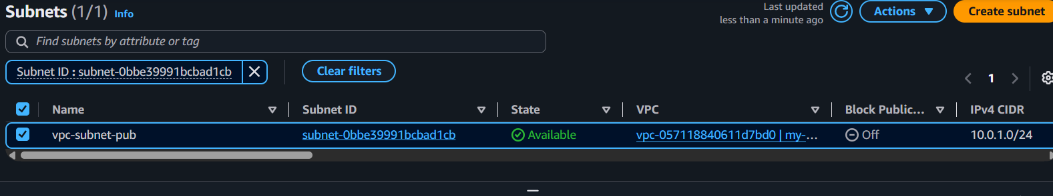

Step 3: Create a Private Subnet
- Click Create subnet again.
- Select My-VPC.
- Enter:
  - Subnet name: Private-Subnet
  - Availability Zone: Same or another AZ
  - IPv4 CIDR: 10.0.2.0/24
- Click Create subnet.
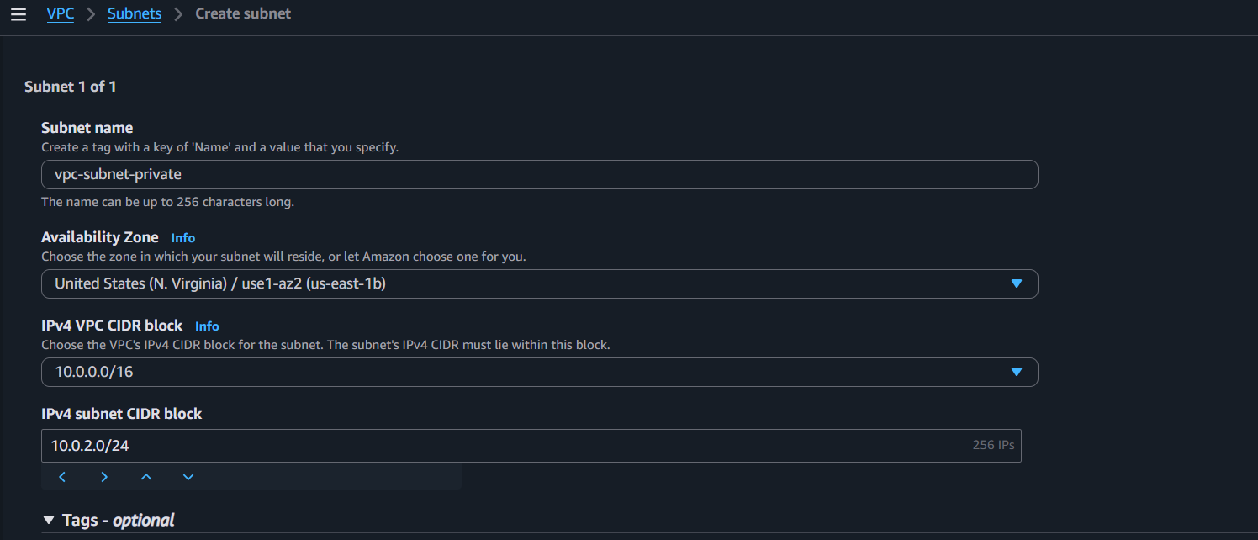
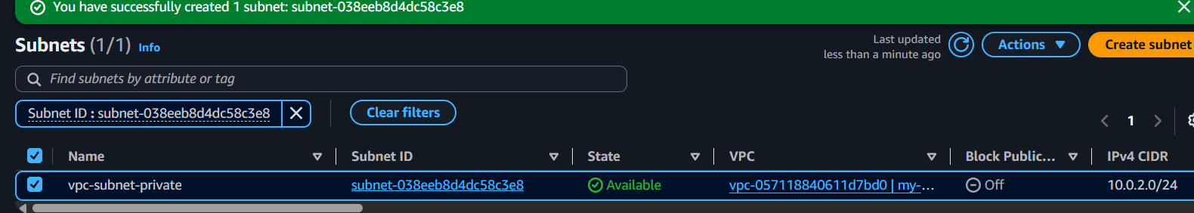

Step 4: Enable Auto-Assign Public IP (Public Subnet Only)
- Go to Subnets.
- Select Public-Subnet.
- Click Actions → Edit subnet settings.
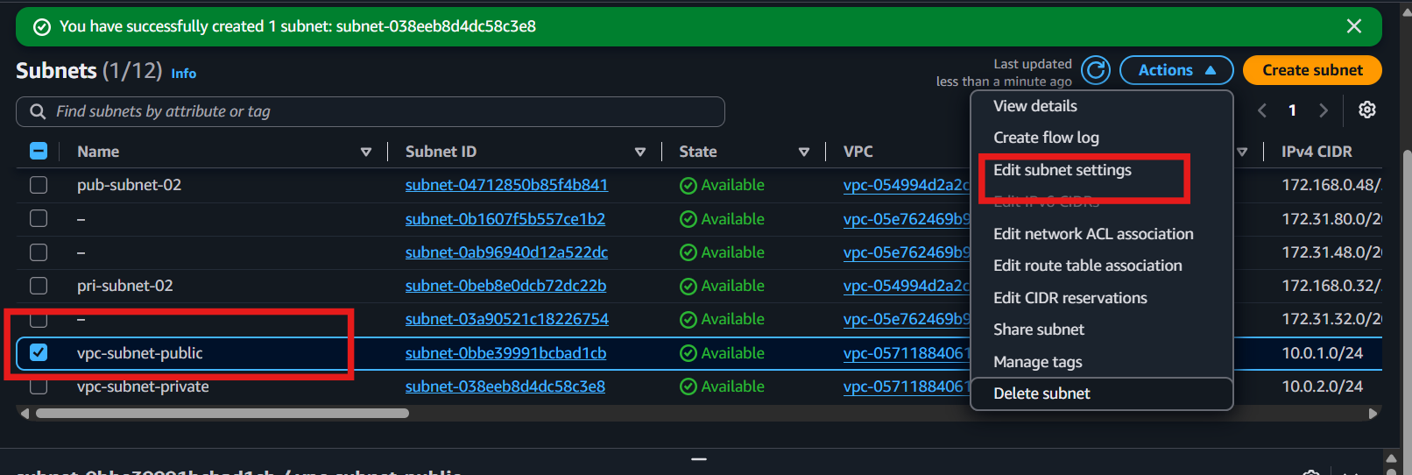
- Check Enable auto-assign public IPv4 address.
- Click Save.
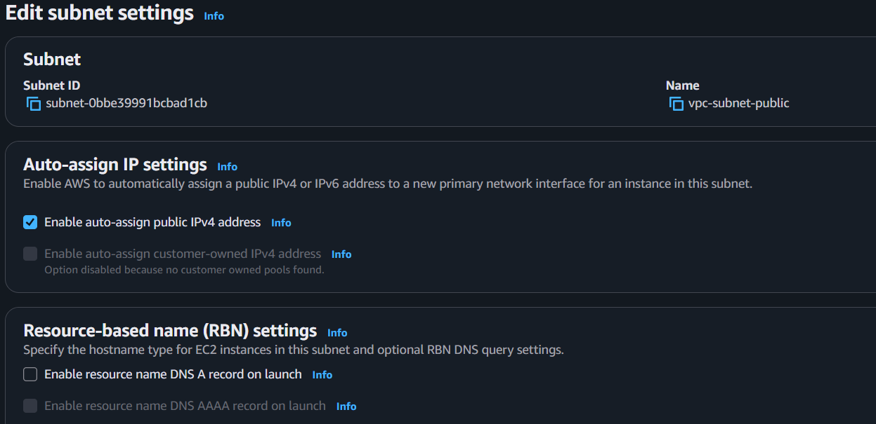

Step 2: Assign the IGW to the Public Subnet (via Route Table)
- Go to Route Tables.
- Create or select the Public Route Table.
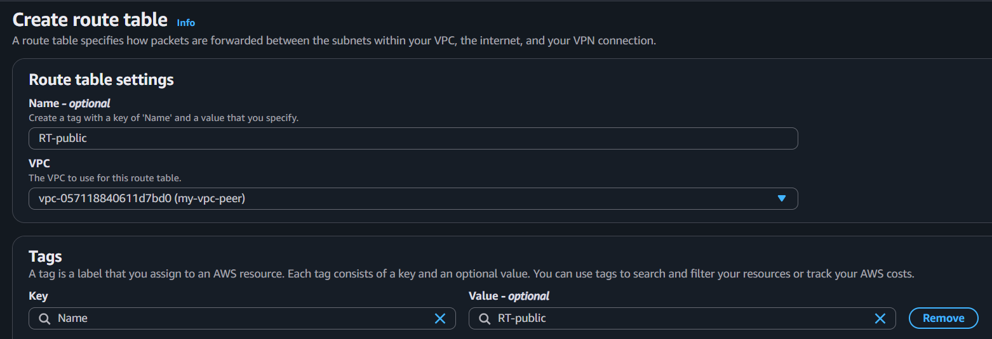
- Click the Routes tab.
- Click Edit routes.
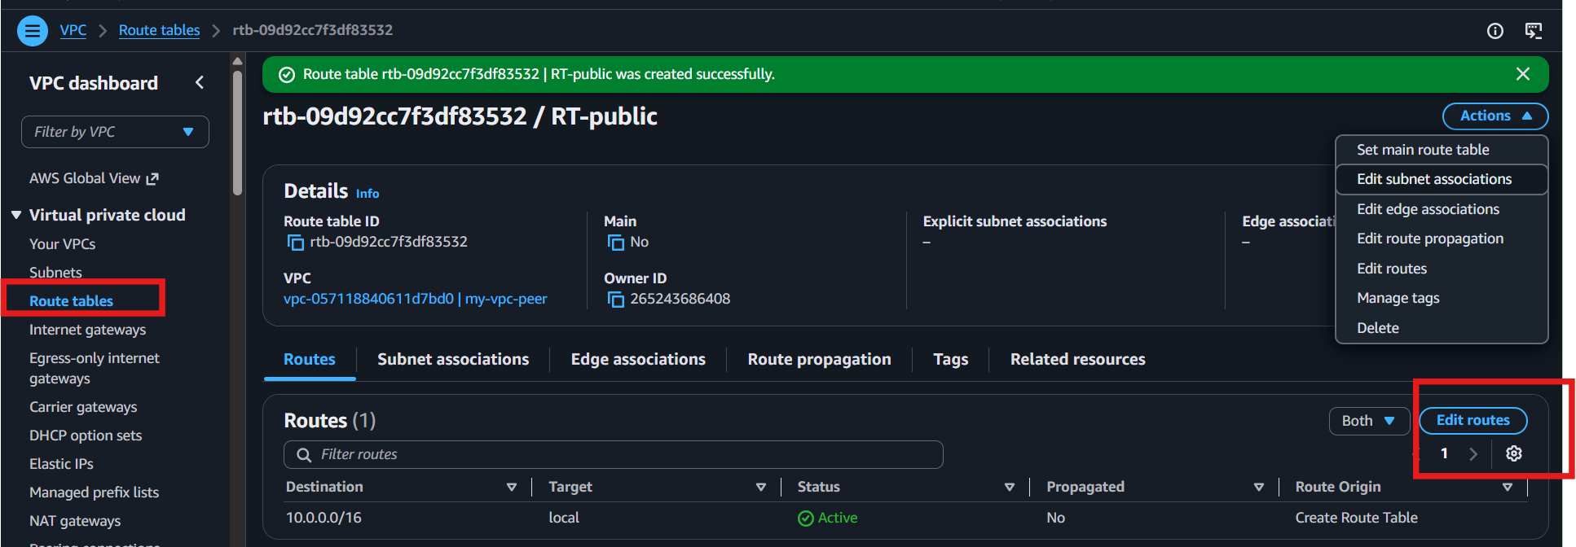
- Add
  - Destination: 0.0.0.0/0
  - Target: Select your Internet Gateway (IGW)

- Save the route.

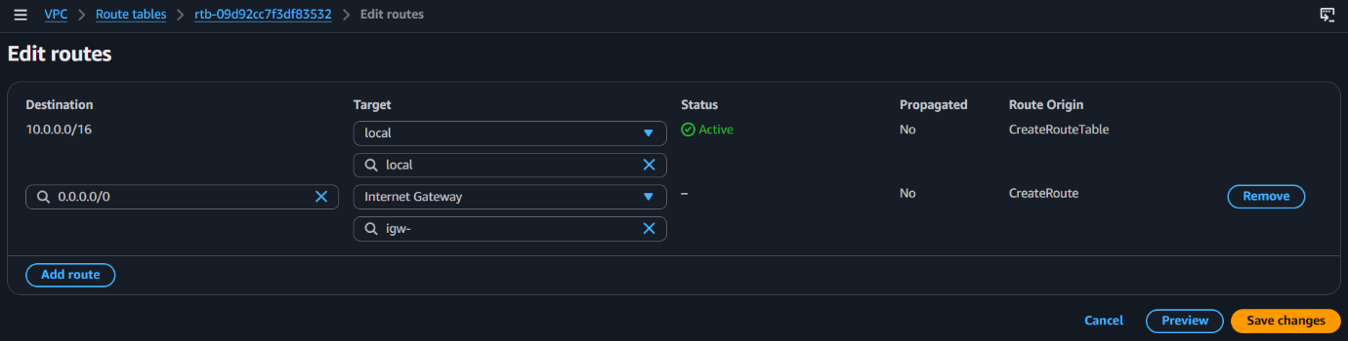
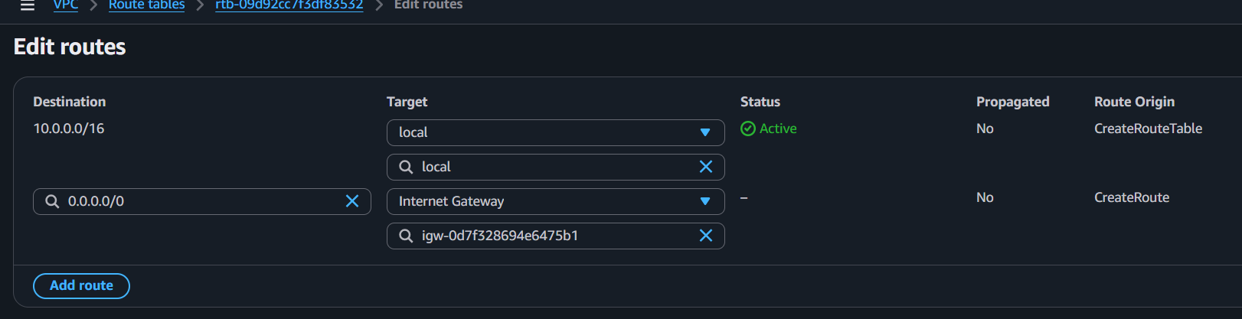
2) Enable VPC peering for cross-region.
Creating two vpc’s
Step 1: Create another VPC in a different Region
- Switch to another AWS Region (ohio).
- Create VPC-Ohio
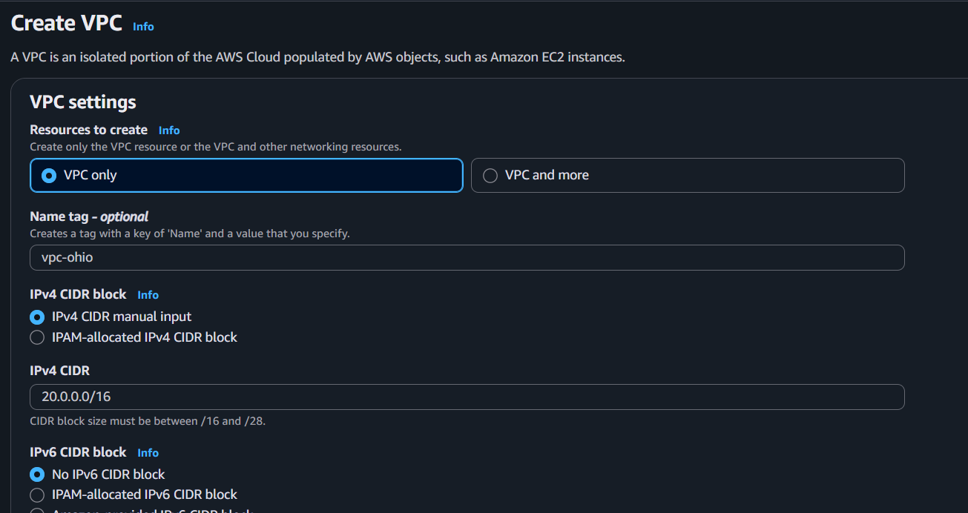
- Use a different CIDR (Example: 20.0.0.0/16).

Step 2: Create another VPC in a different Region
- Switch to another AWS Region (Virginia).
- Create VPC- Virginia

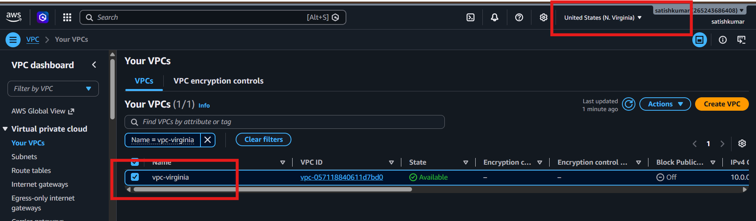

Step 2: Create VPC Peering
- Go to VPC Console → Peering Connections
- Click Create Peering Connection
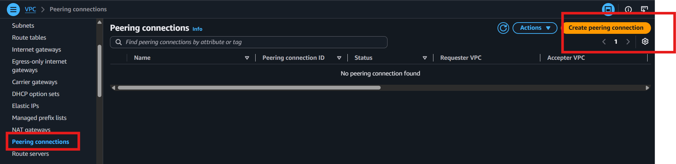
Enter:
- Name: Cross-Region-Peering
- Requester VPC: VPC-Verginia
- Accepter Region: Select the other Region
- Accepter VPC: VPC-Ohio
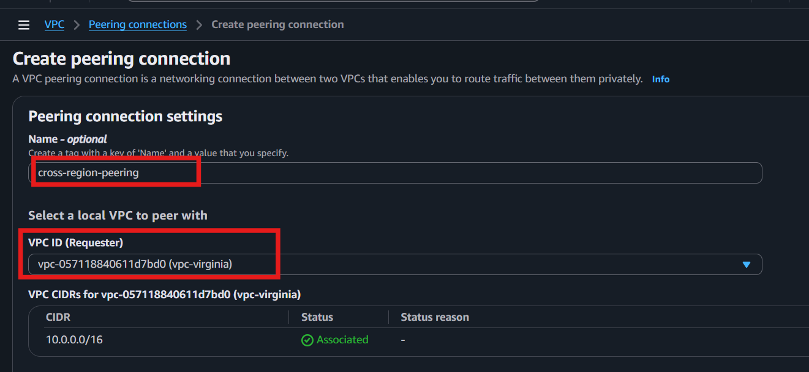
Click Create.

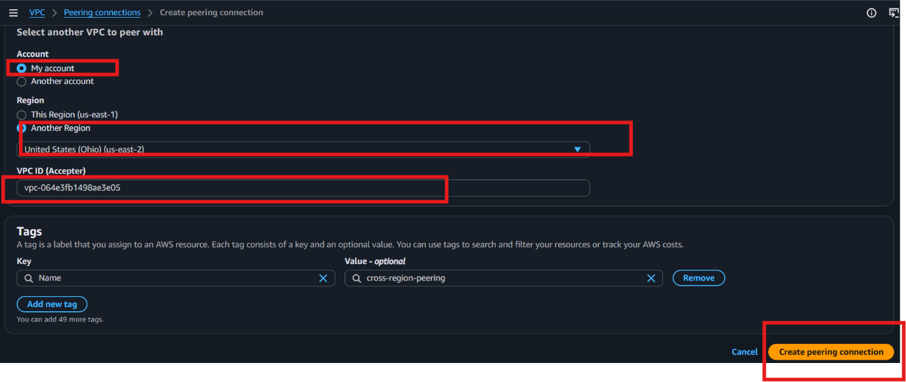

Step 3: Accept the Peering Request
- Switch to the second Region.
- Go to VPC → Peering Connections.
- Select the pending request.
- Click Actions → Accept Request.
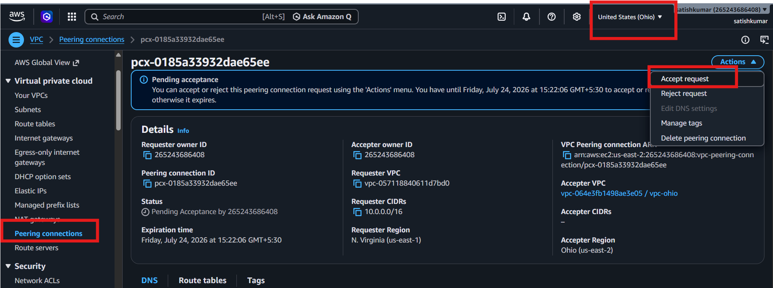

Step 4: Update Route Table (VPC-Verginia)
- Go to Route Tables.
- Select the route table of VPC-Verginia.
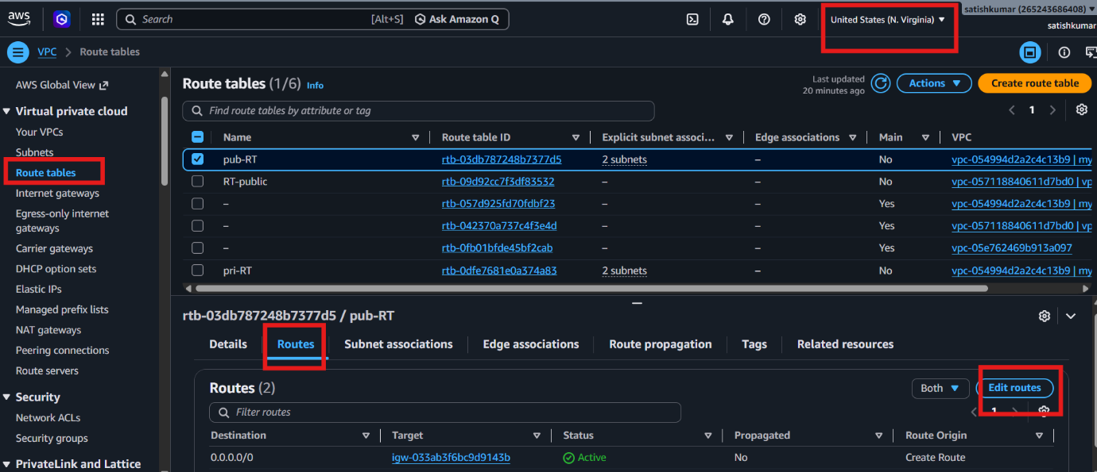
- Click Edit Routes → Add Route.

- Destination: CIDR of VPC-Ohio (e.g., 20.0.0.0/16)
- Target: VPC Peering Connection (pcx-xxxxx)
- Save.
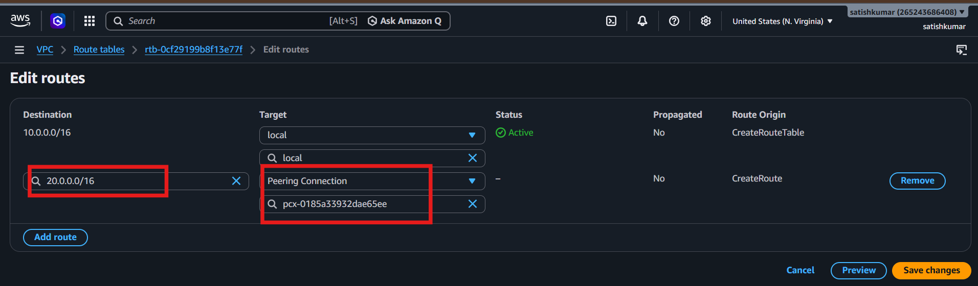

Step 5: Update Route Table (VPC-Ohio)
- Switch to the second Region.
- Go to Route Tables.
- Select the route table of VPC-Ohio
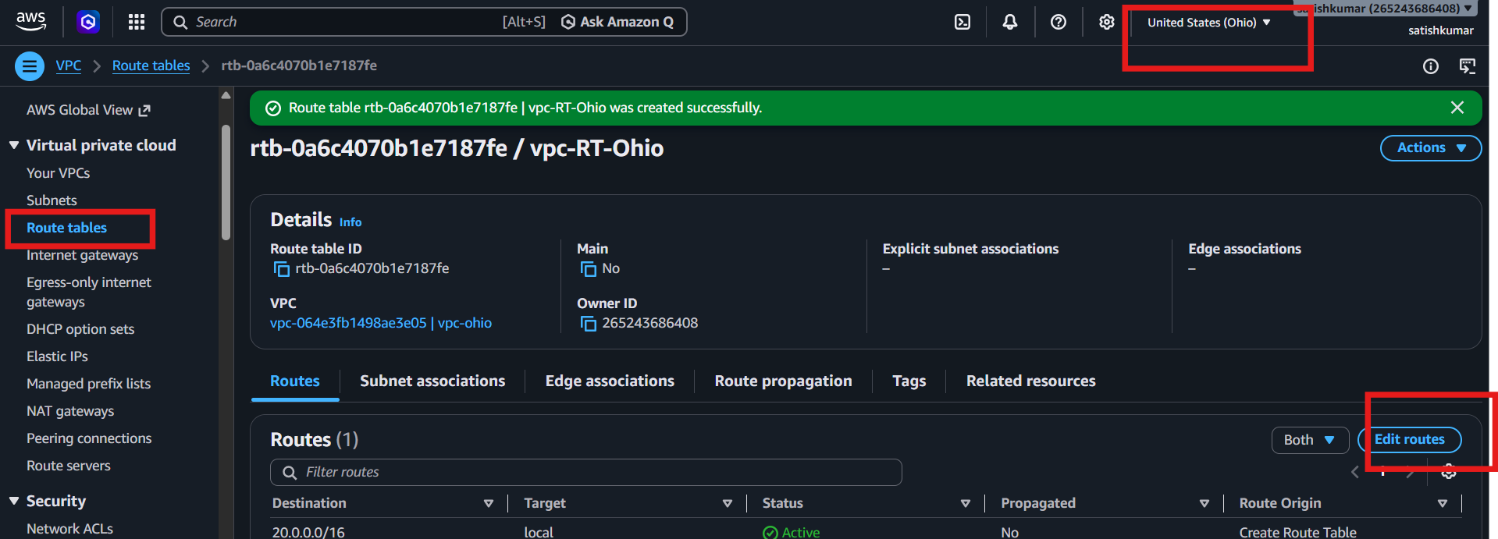
- Click Edit Routes → Add Route.
- Destination: CIDR of VPC-1 (e.g., 10.0.0.0/16)
- Target: VPC Peering Connection (pcx-xxxxx)
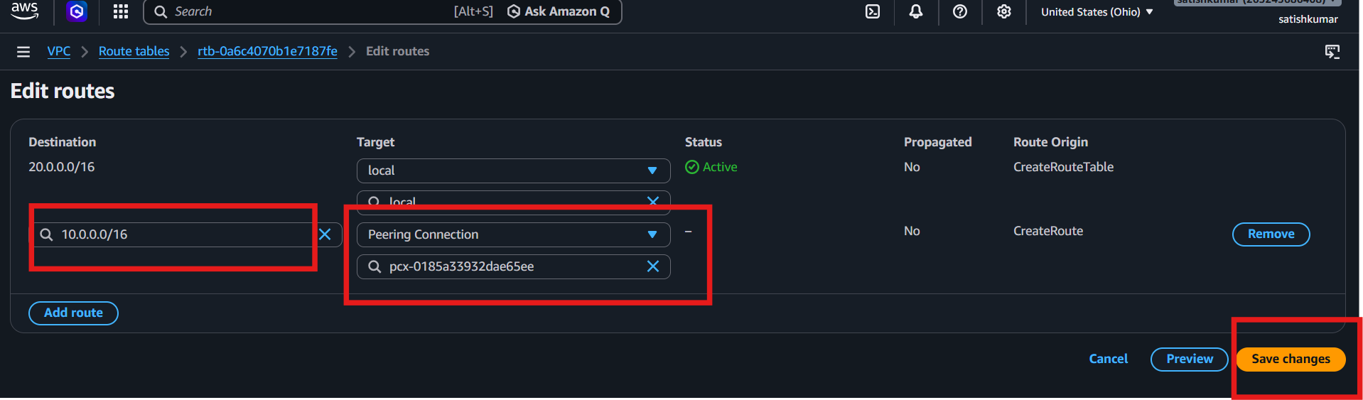

Step 7: create EC2 instance for both regions
Virginia
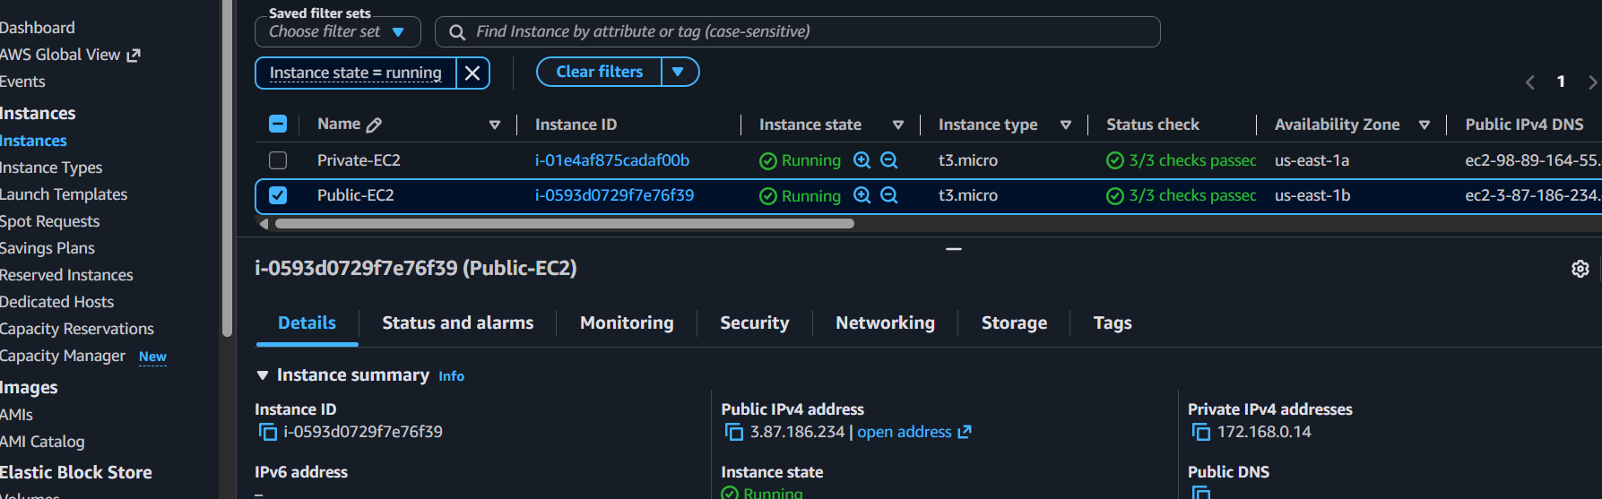
Ohio-Ec2
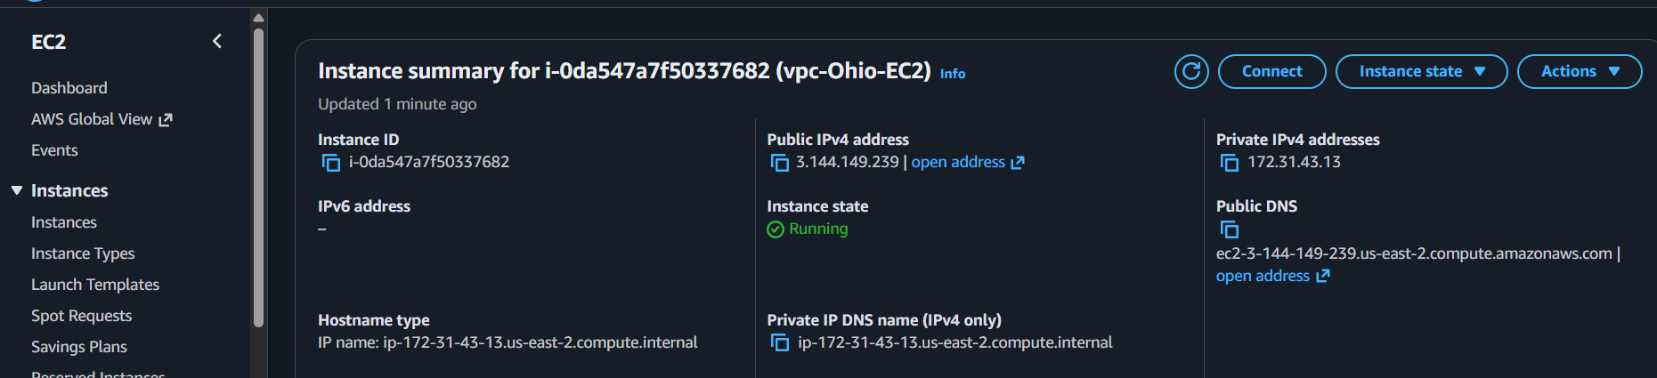
Step 6: Update Security Groups
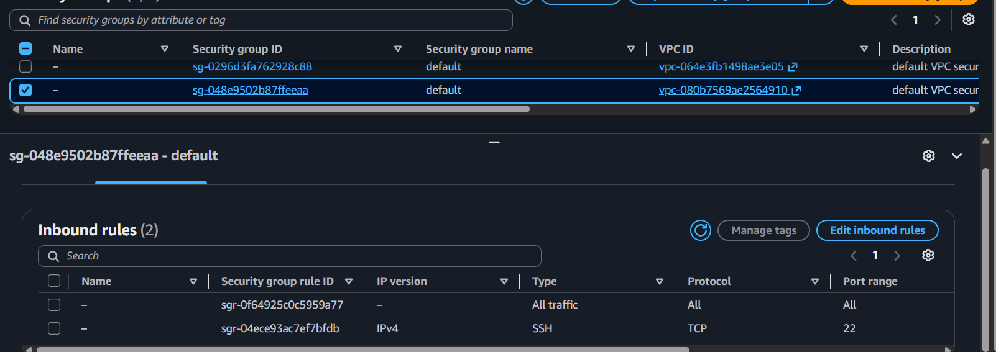

Step 7: Test Connectivity
- Launch EC2 instances in both VPCs (optional but recommended).
- Try ping or SSH using the private IP addresses.
✅ Cross-Region VPC Peering is complete.
Tip: Make sure the CIDR blocks do not overlap (for example, 10.0.0.0/16 and 20.0.0.0/16).

3) Enable VPC peering for cross-account (you can collaborate with your friend to do this task).
Account A (Requester):
- Sign in to AWS Console → VPC.
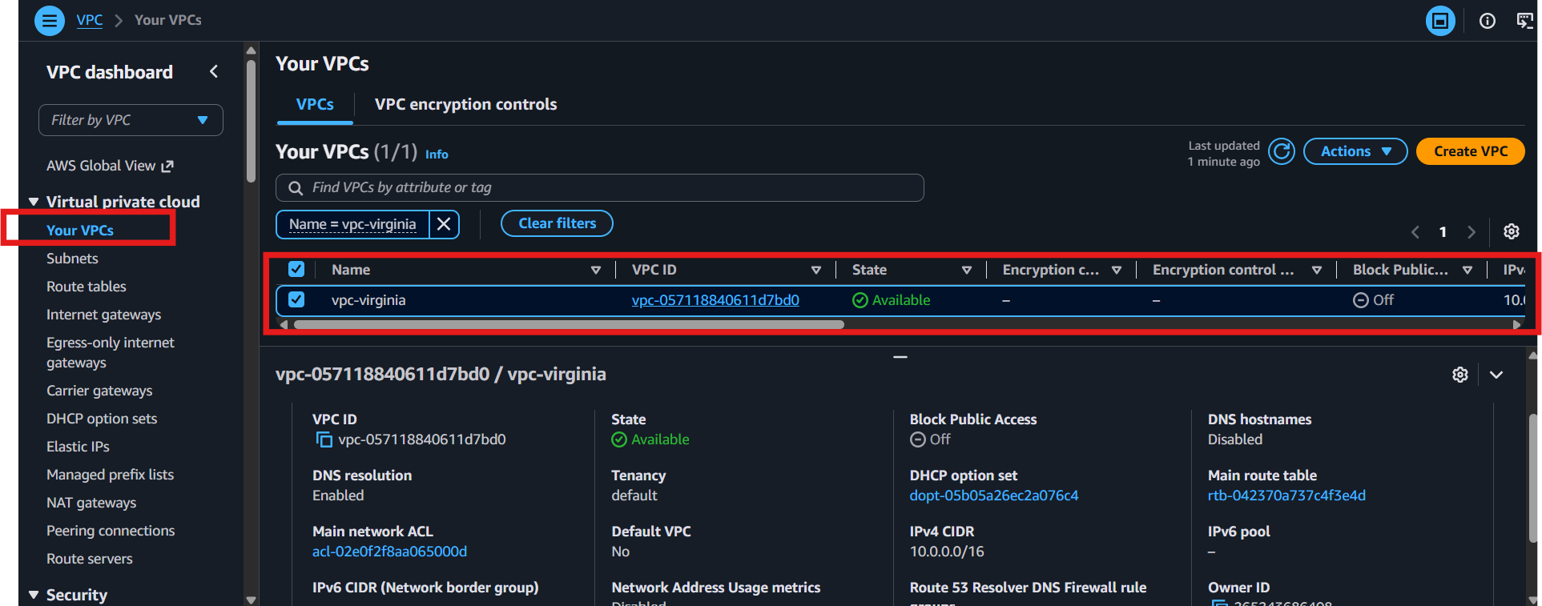
- Go to Peering Connections → Create Peering Connection.
- Enter a name.
- Select Requester VPC (your VPC).
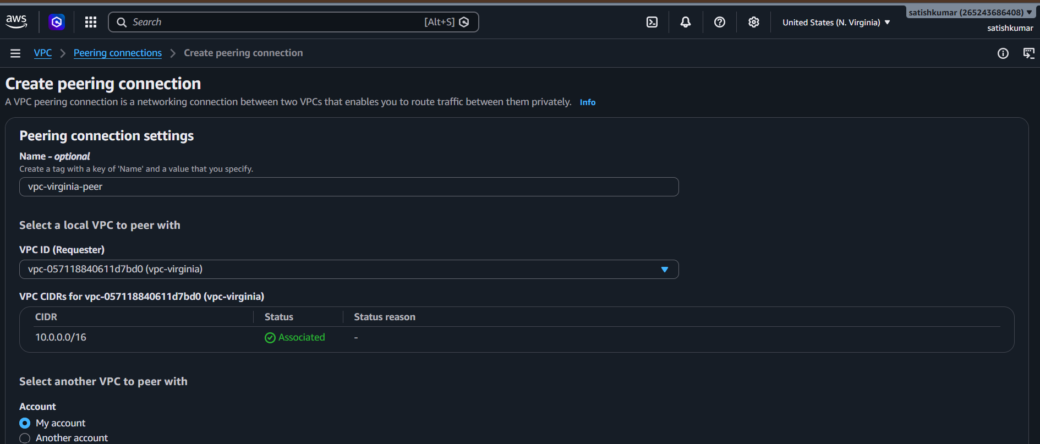

- Select Another AWS Account.
- Enter your friend's AWS Account ID.
- Select your friend's VPC ID and Region.
- Click Create Peering Connection.
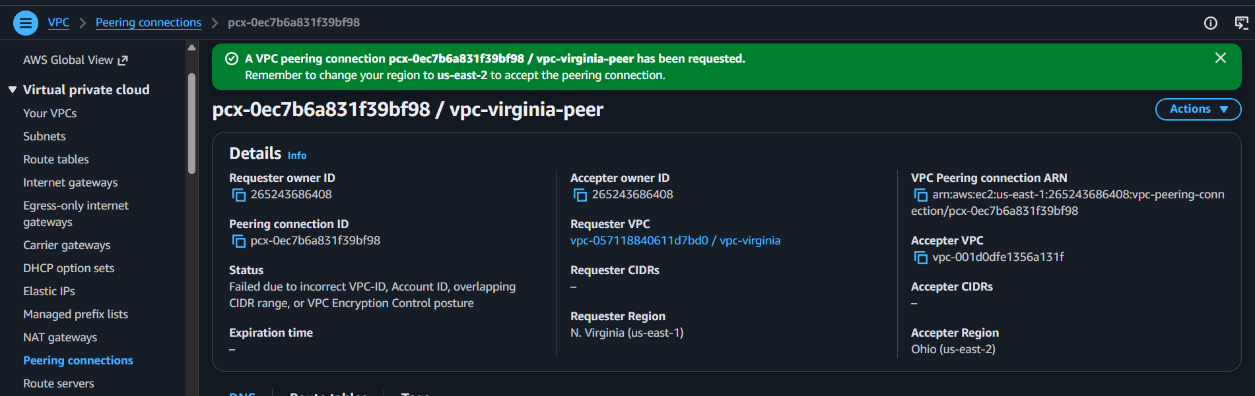
Account B (Accepter):
9. Sign in to AWS → VPC → Peering Connections.
10. Select the pending request.
11. Click Actions → Accept Request.
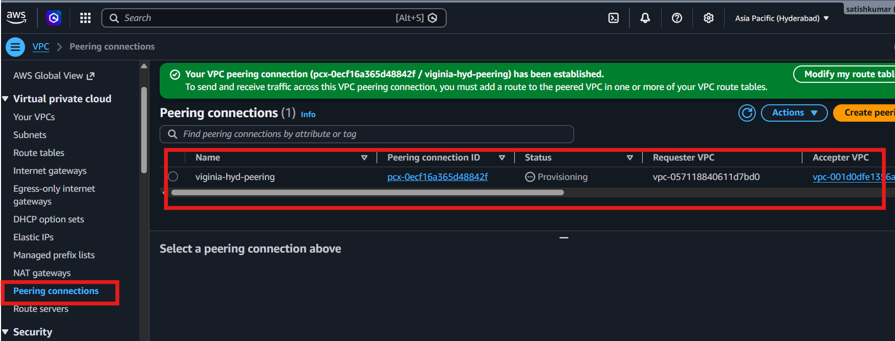
Update Route Tables (Both Accounts):
12. Open Route Tables.
13. Edit routes.
14. Add:
- Destination: Other VPC CIDR
- Target: VPC Peering Connection (pcx-xxxxxxxx)
Save the route.
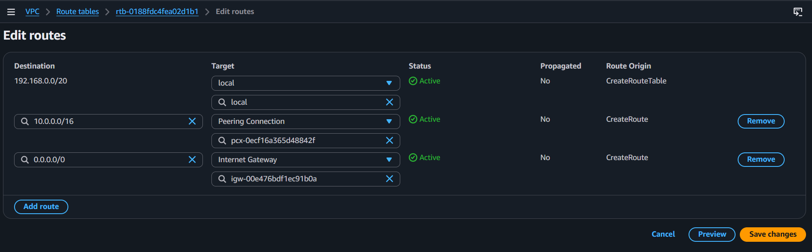
Update Security Groups
16. Add inbound rules to allow required traffic

Test Connectivity:
17. Launch EC2 instances in both VPCs.
18. Ping the private IP or SSH between the instances to verify connectivity.
EC2-virginia-Region
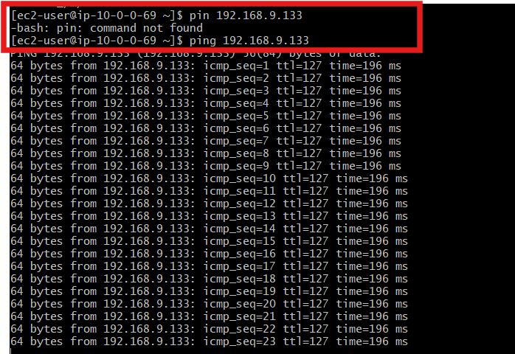
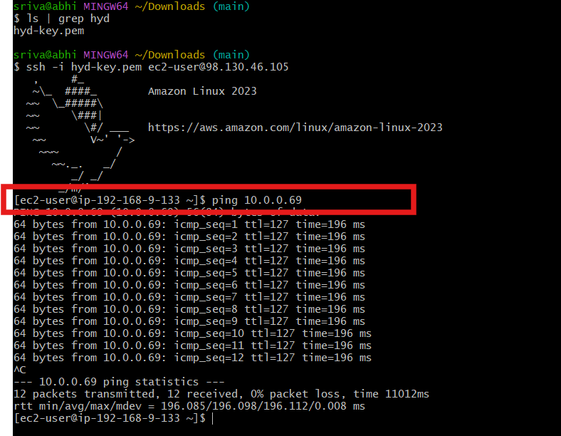
EC2-hyd-Region

4) Set up a VPC Transit Gateway.
Step:1
Using 4 VPC’s
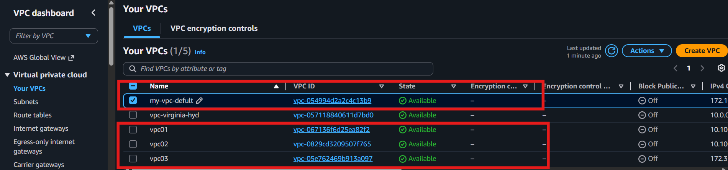
Step:2
Created subnets for VPC’s
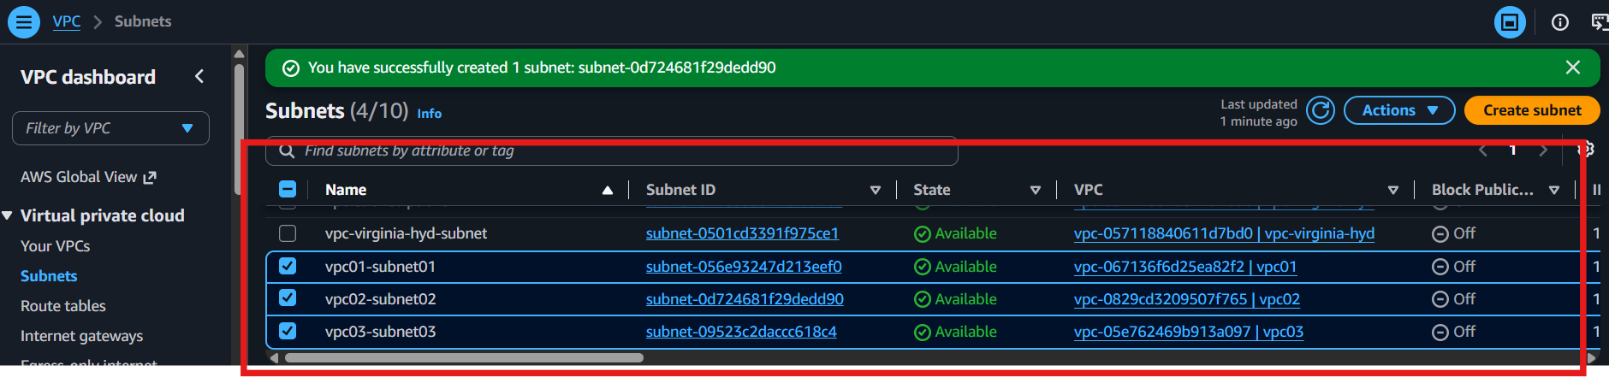

Step:3
1. Create a Transit Gateway
- Go to VPC Console.
- Click Transit Gateways → Create Transit Gateway.
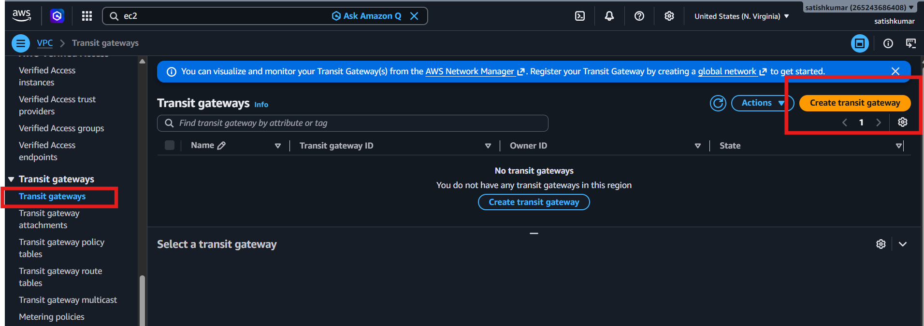

- Enter a Name.
- Leave default settings.
- Click Create Transit Gateway.
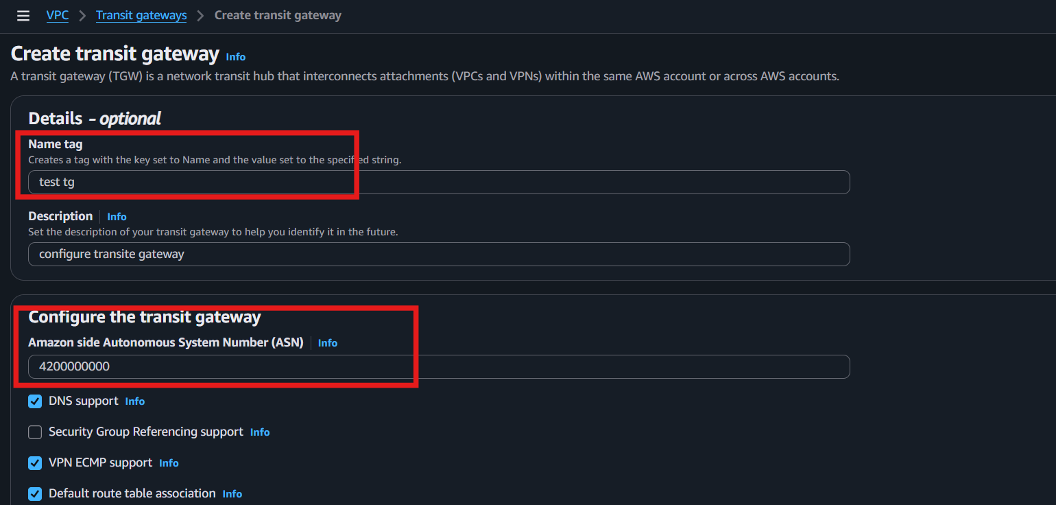
2. Create Transit Gateway Attachments
- Go to Transit Gateway Attachments → Create Attachment.
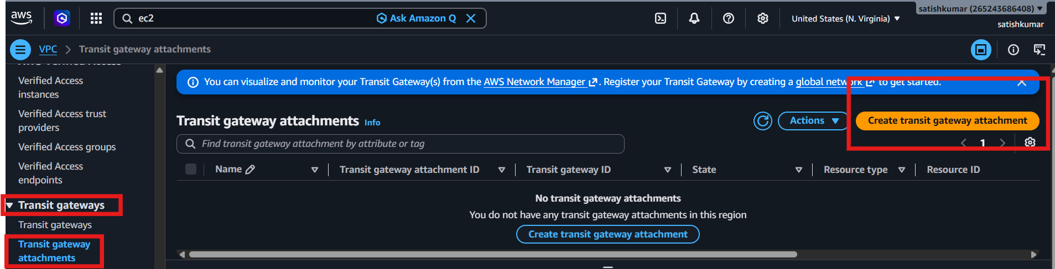
- Select:
  - Name: defult-tga
  - Resource Type: VPC
  - Transit Gateway: test-tgw
  - VPC: my-vpc-defult
  - Subnet: defult subnet
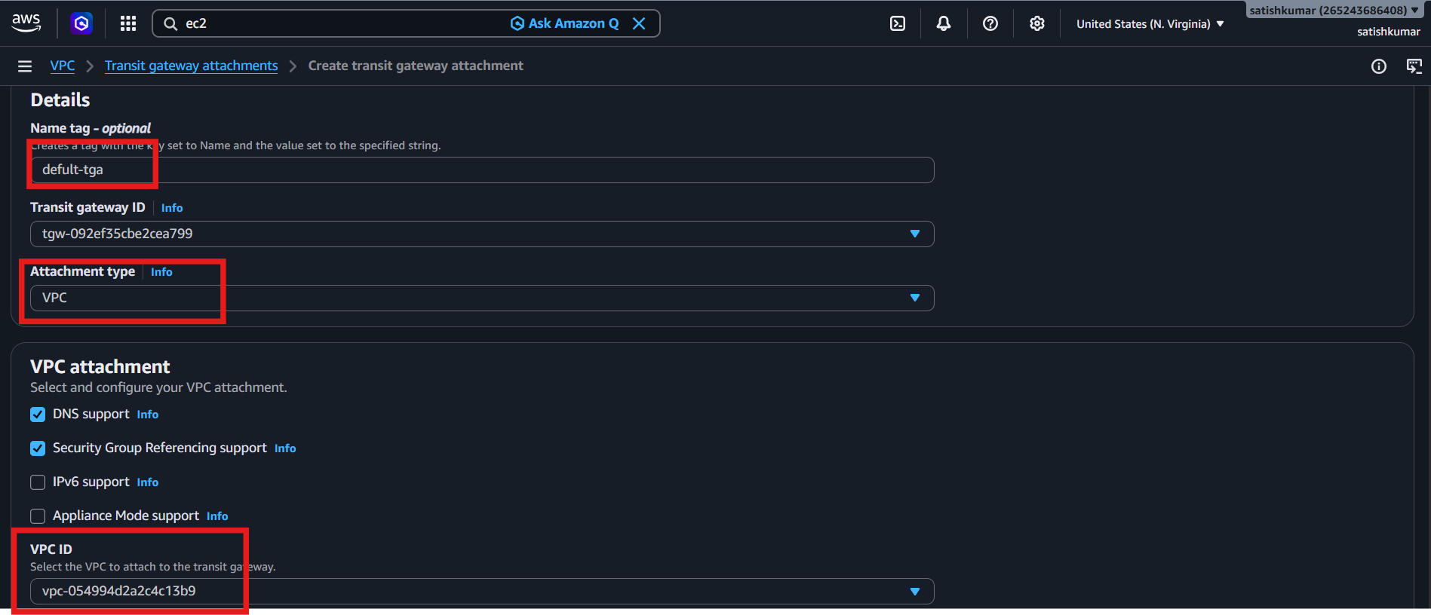
- Click Create Attachment.
- Repeat for each VPC you want to connect.
Vpc01
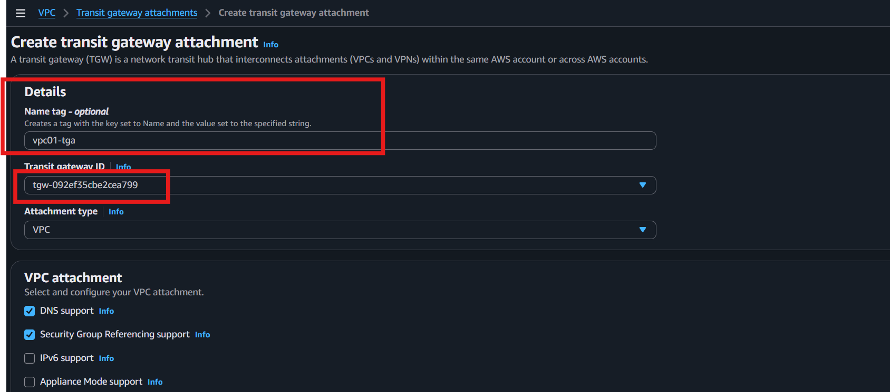
Vpc02
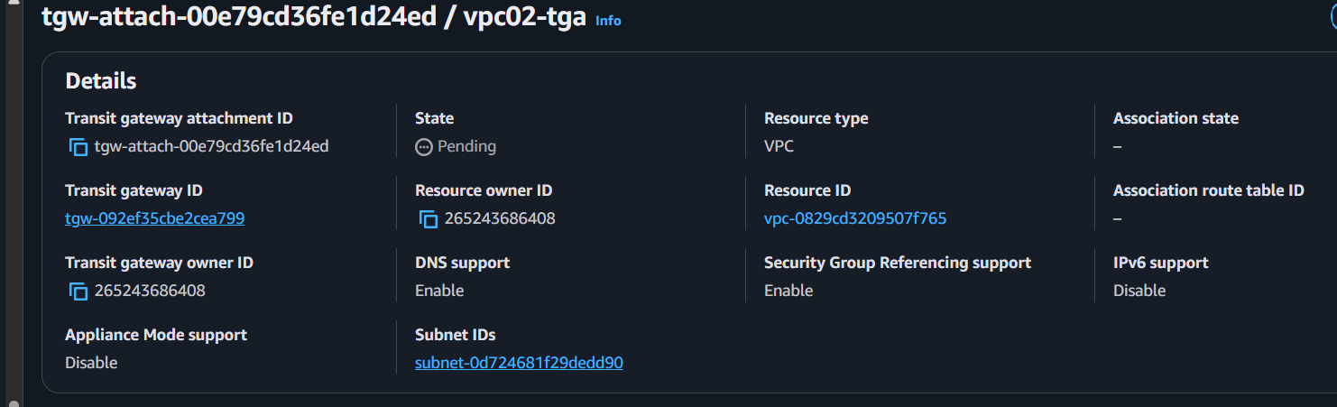
Vpc03
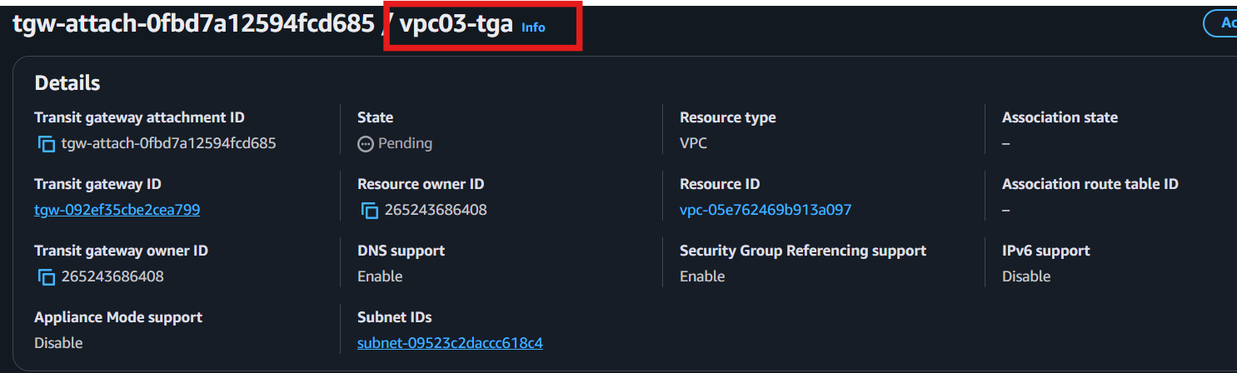

Check
VPC---Transit gateway route table-Association
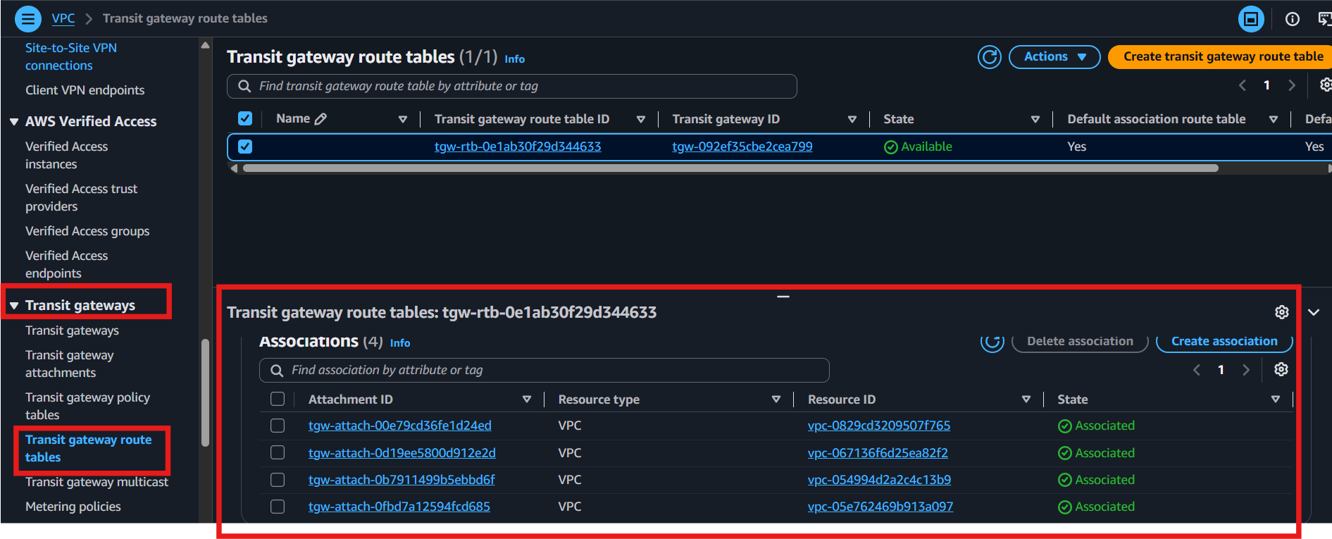
Check
VPC---Transit gateway route table-Route
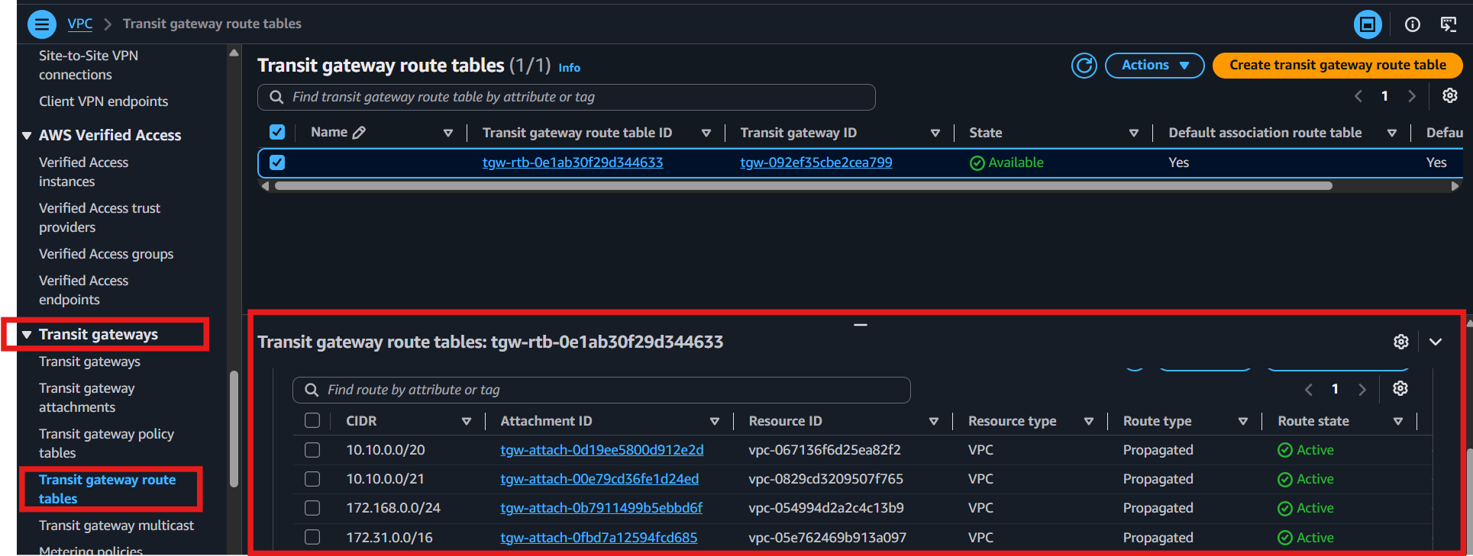

Now Launch 4 EC2 instance in 4vpc
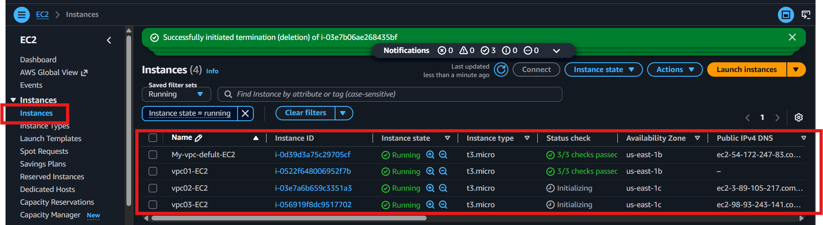

4. Update Security Groups
- Allow required traffic
SSH and all Traffic
5. Test Connectivity
- From one EC2 instance, ping the private IP of an EC2 in the other VPC:
Error
Host unreachable:
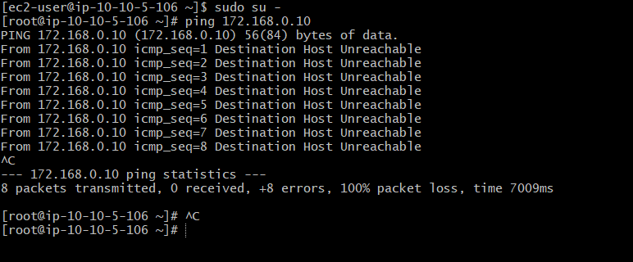
Solution
Update route table
Destination and target
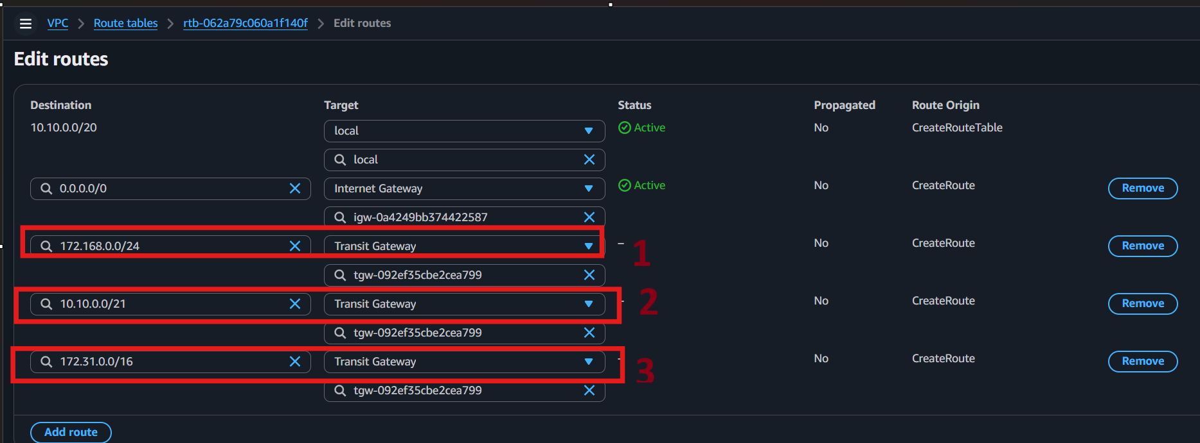

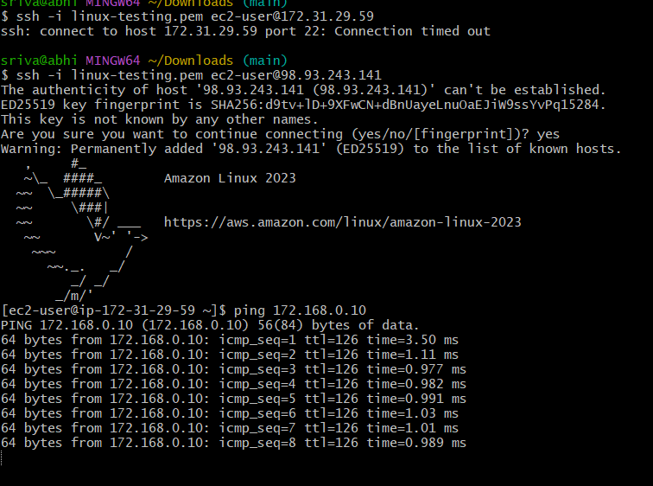
Connected
5) Set up a VPC Endpoint.
Create 2 instance public and private instances
Step 1: Launch Public EC2
- Name: pub-EC2
- AMI: Amazon Linux
- Key Pair: linux-testing
- VPC: Select your VPC
- Subnet: pub-subnet
- Firewall: Existing → default
- Click Launch Instance

Step 2: Launch Private EC2
- Name: priv-EC2
- AMI: Amazon Linux
- Key Pair: linux-testing
- VPC: Select your VPC
- Subnet: priv-subnet
- Auto Assign Public IP: Disable
- Security Group: Existing → default
- Click Launch Instance

Step 3: Create an S3 Bucket
- Go to S3.
- Create a new bucket (or use an existing bucket).
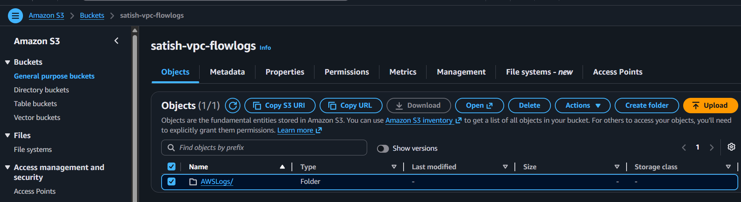

Step 4: Connect to Public EC2
- Go to EC2 → Select pub-EC2 → Connect → Copy SSH.
- Open Git Bash and connect to the instance.
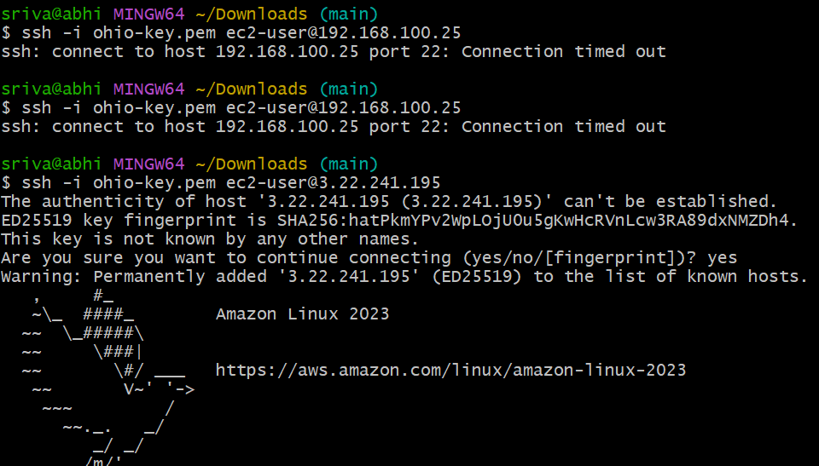

Step 5: Configure AWS CLI
Run the following commands:
aws --version
aws s3 ls
aws configure
Enter:
- Access Key
Go accounts security credentials create access key
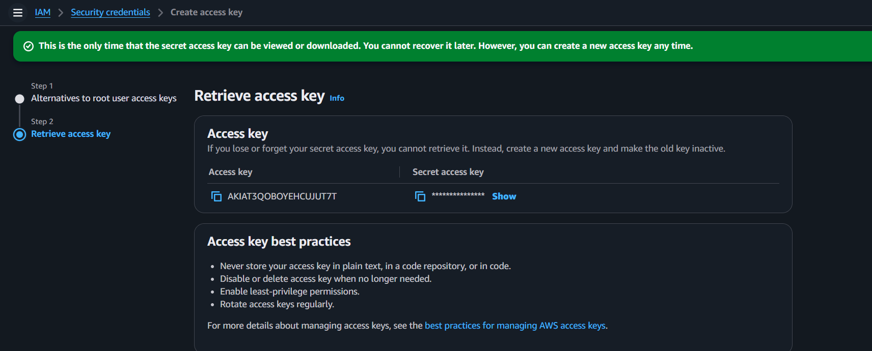
- Secret Key
- Region: us-east-1
- Output Format: json
Verify:
aws s3 ls
Output: Your S3 bucket name is displayed.
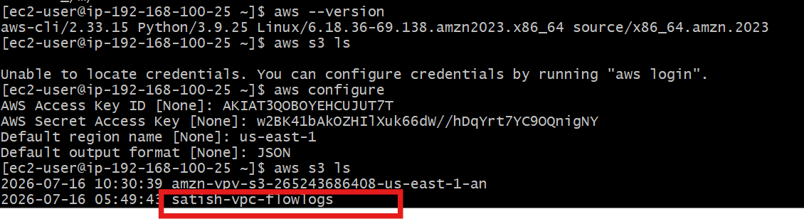

Step 6: Verify AWS Profile
Run the following commands:
find / -name profile
ls
ls -a
cd .aws
pwd
cat config
cat credentials
aws s3 ls --profile default
Output:
- Config and credentials are displayed.
- The default profile is shown.
- S3 bucket list is displayed successfully.
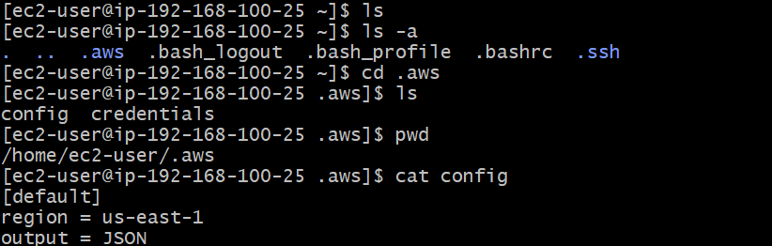

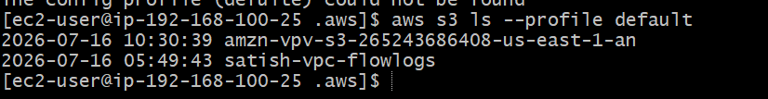

Result: AWS CLI is configured successfully, and the EC2 instance can access Amazon S3 through the configured profile.

Note: For most AWS lab assignments, creating an S3 Gateway Endpoint is the expected task. 